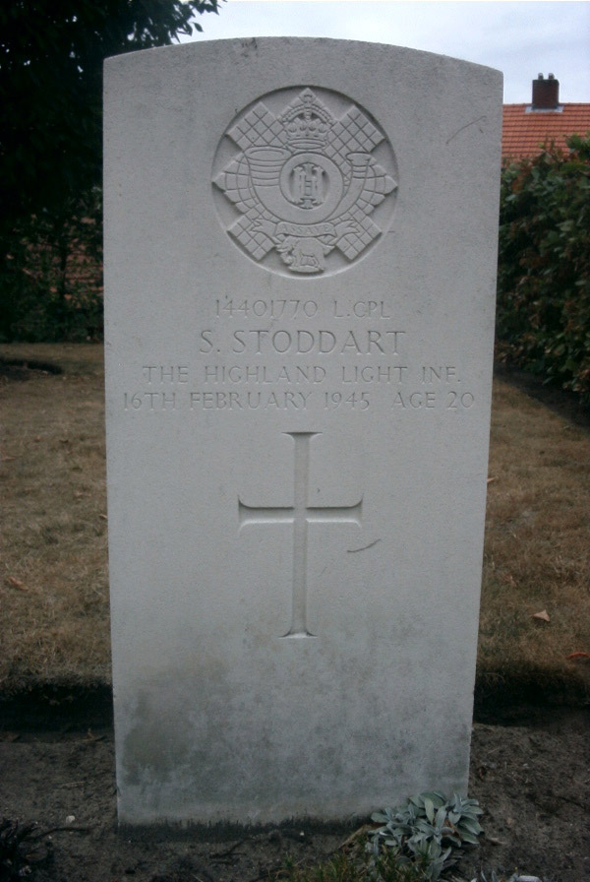 | 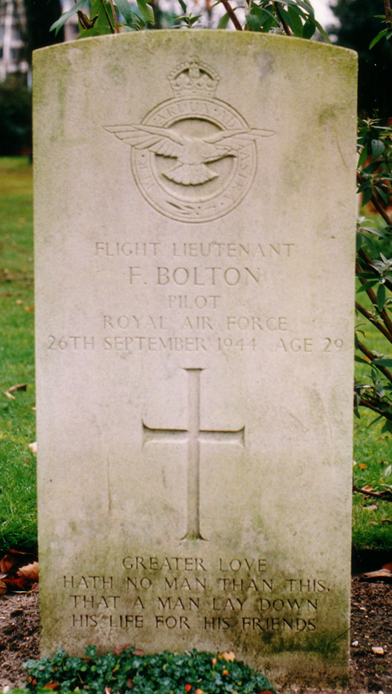
Lance Corporal Sidney STODDART  5th Battalion, The Highland Light Infantry,  (City of Glasgow Regiment), 157th Infantry  Brigade,  52nd (Lowland) Infantry Division  KIA 16-02-1945  Veldgraf: F. Derks, Nijmeegscheweg  Begraven: Milsbeek War Cemetery II.G.15 | Flight Lieutnant Frank BOLTON  Pilot 168 Squadron, RAF  KIA 26-09-1944  Veldgraf: R.K. Kerkhof Noordzijde  Begraven: Jonkerbos War Cemetery 17.G.1

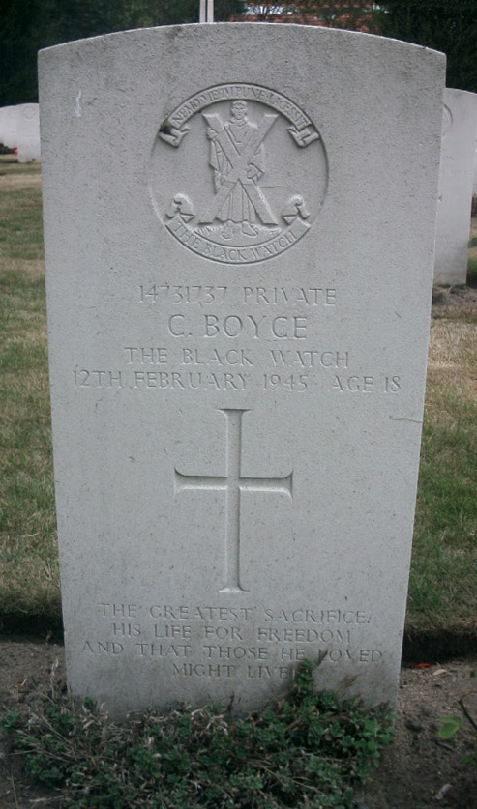 | 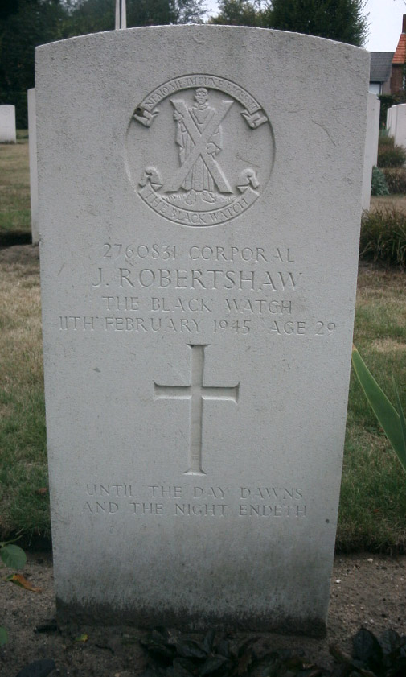
Private Charles BOYCE  5th Battalion, Black Watch (Royal Highlanders),  153rd Infantry Brigade,  51st (Highland) Infantry Division  KIA 12-02-1945  Veldgraf: P.J.. Geurts, Nijmeegscheweg 27  Begraven: Milsbeek War Cemetery II.A.1 | Corporal John ROBERTSHAW  5th Battalion, Black Watch (Royal Highlanders),  153rd Infantry Brigade,  51st (Highland) Infantry Division  KIA 11-02-1945  Veldgraf: P.J.. Geurts, Nijmeegscheweg 27  Begraven: Milsbeek War Cemetery II.A.2

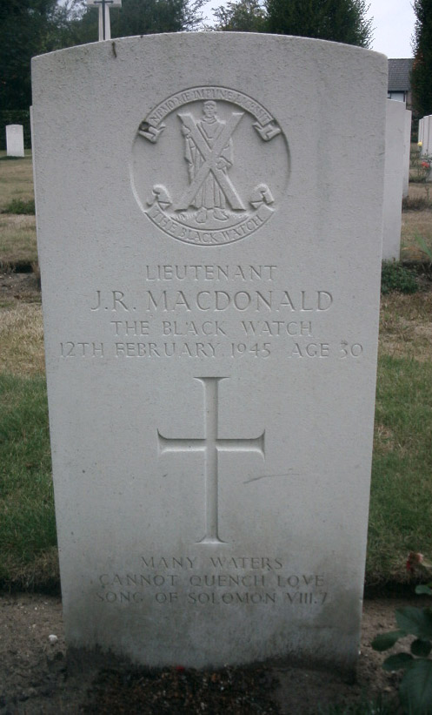 | 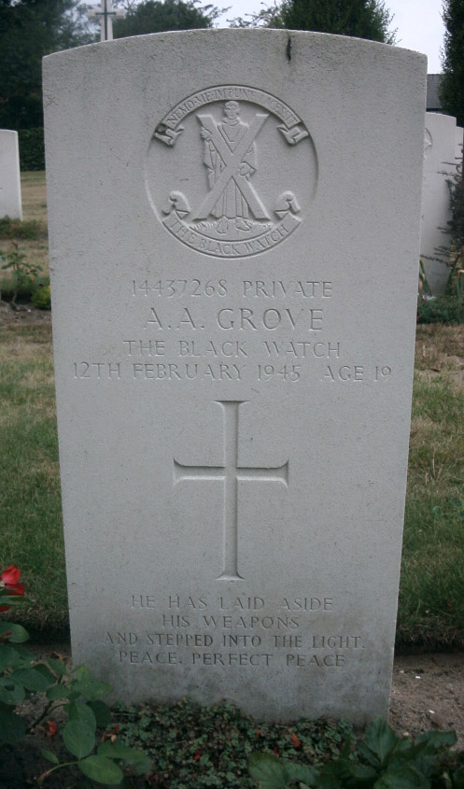
Lieutnant Jean R. MACDONALD  5th Battalion, Black Watch (Royal Highlanders),  153rd Infantry Brigade,  51st (Highland) Infantry Division  KIA 12-02-1945  Veldgraf: P.J. Geurts, Nijmeegscheweg 27  Begraven: Milsbeek War Cemetery II.A.3 | Private Albert A. GROVE  5th Battalion, Black Watch (Royal Highlanders),  153rd Infantry Brigade,  51st (Highland) Infantry Division  KIA 12-02-1945  Veldgraf: P.J. Geurts, Nijmeegscheweg 27  Begraven: Milsbeek War Cemetery II.A.4

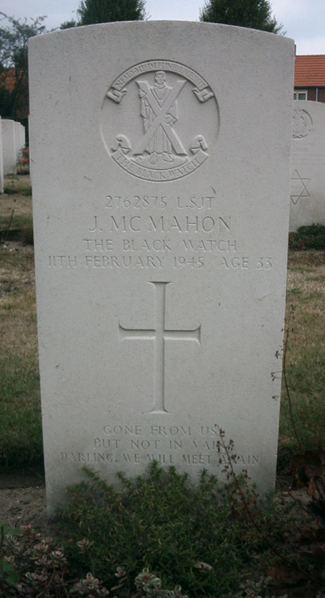 | 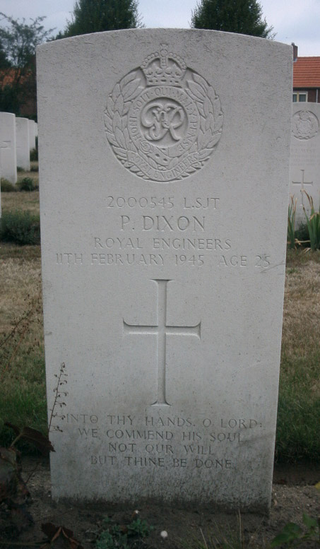
Lance Serjeant James MCMAHON  5th Battalion, Black Watch (Royal Highlanders),  153rd Infantry Brigade,  51st (Highland) Infantry Division  KIA 11-02-1945  Veldgraf: P.J. Geurts, Nijmeegscheweg 27  Begraven: Milsbeek War Cemetery II.A.10 | Lance Serjeant Peter DIXON  14 Field Squadron, Royal Engineers,  Guards Armoured Division  KIA 11-02-1945  Veldgraf: P.J. Geurts, Nijmeegscheweg 27  Begraven: Milsbeek War Cemetery II.A.11

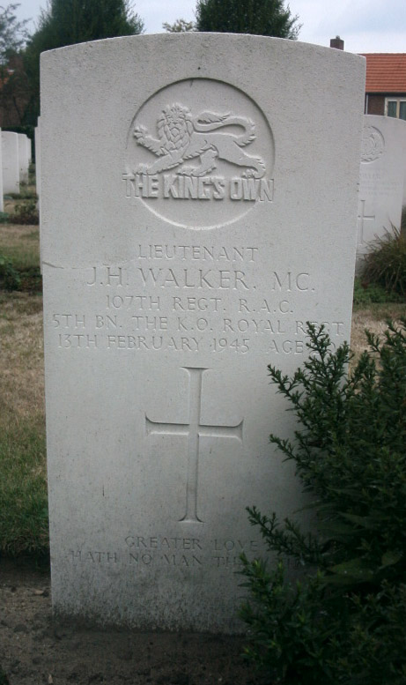 | 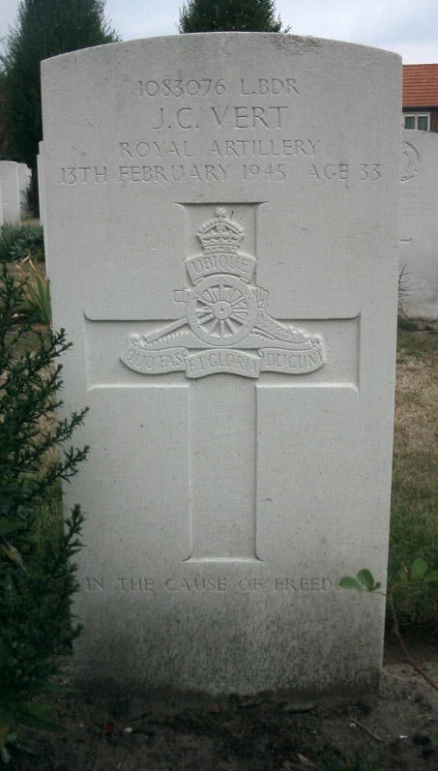
Lieutnant John H. WALKER  107th (5th Bn. The King's Own Royal Regt. [Lancaster]) Regt, R.A.C.,  34th Army Tank Brigade  KIA 13-02-1945  Veldgraf: P.J. Geurts, Nijmeegscheweg 27  Begraven: Milsbeek War Cemetery II.A.12 | Lance Bombardier John C. VERT  127 Field Regiment, RA,  51st (Highland) Infantry Division  KIA 13-02-1945  Veldgraf: P.J. Geurts, Nijmeegscheweg 27  Begraven: Milsbeek War Cemetery II.A.13

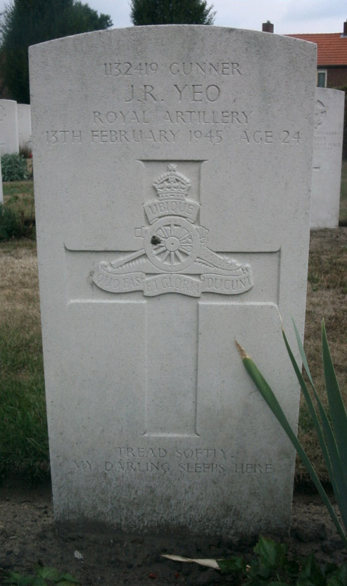 | 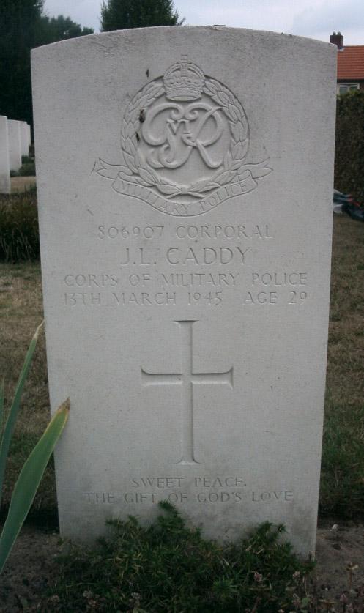
Gunner John R. YEO  127 Field Regiment, RA,  51st (Highland) Infantry Division  KIA 13-02-1945  Veldgraf: P.J. Geurts, Nijmeegscheweg 27  Begraven: Milsbeek War Cemetery II.A.14 | Corporal J.L. CADDY  Corps of Military Police  KIA 13-03-1945  Veldgraf: P.J. Geurts, Nijmeegscheweg 27  Begraven: Milsbeek War Cemetery II.A.15

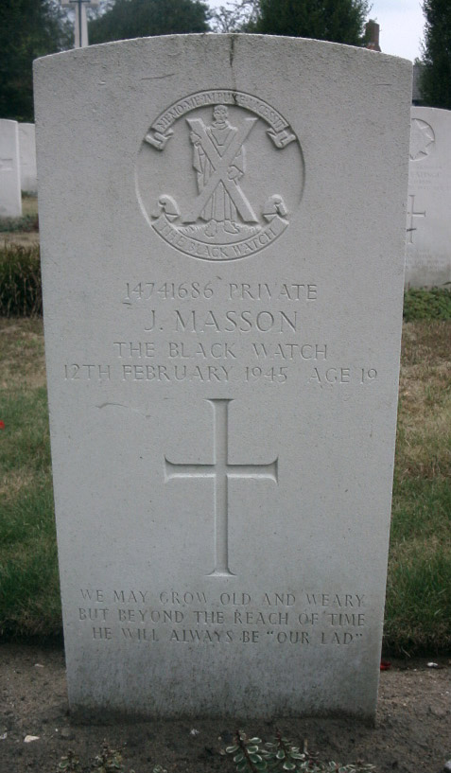 | 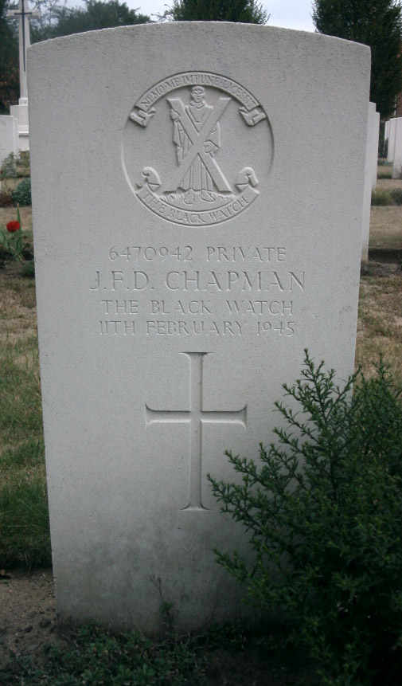
Private Joseph MASSON  5th Battalion, Black Watch (Royal Highlanders),  153rd Infantry Brigade,  51st (Highland) Infantry Division  KIA 12-02-1945  Veldgraf: P.J. Geurts, Nijmeegscheweg 27  Begraven: Milsbeek War Cemetery II.A.5 | Private John F.D. CHAPMAN  5th Battalion, Black Watch (Royal Highlanders),  153rd Infantry Brigade,  51st (Highland) Infantry Division  KIA 11-02-1945  Veldgraf: P.J. Geurts, Nijmeegscheweg 27  Begraven: Milsbeek War Cemetery II.A.6

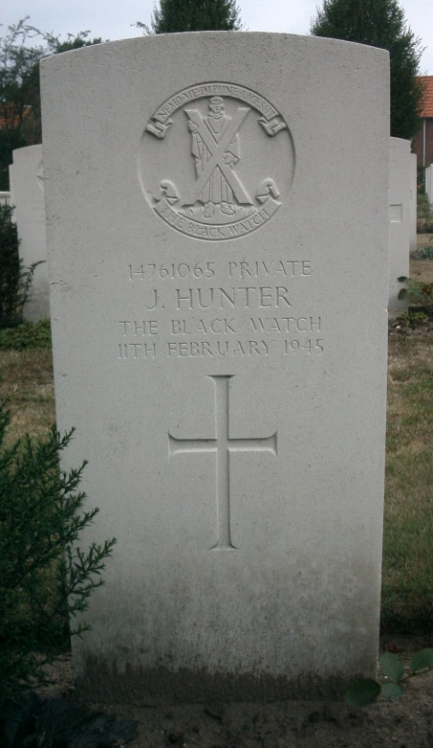 | 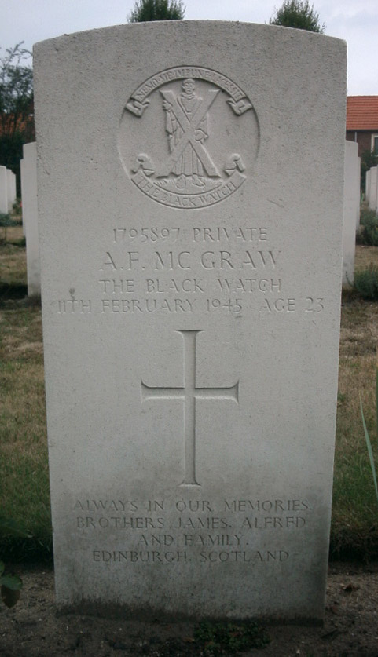
Private James HUNTER  5th Battalion, Black Watch (Royal Highlanders),  153rd Infantry Brigade,  51st (Highland) Infantry Division  KIA 11-02-1945  Veldgraf: P.J. Geurts, Nijmeegscheweg 27  Begraven: Milsbeek War Cemetery II.A.7 | Private Alexander F. MCGRAW  5th Battalion, Black Watch (Royal Highlanders),  153rd Infantry Brigade,  51st (Highland) Infantry Division  KIA 11-02-1945  Veldgraf: P.J. Geurts, Nijmeegscheweg 27  Begraven: Milsbeek War Cemetery II.A.8

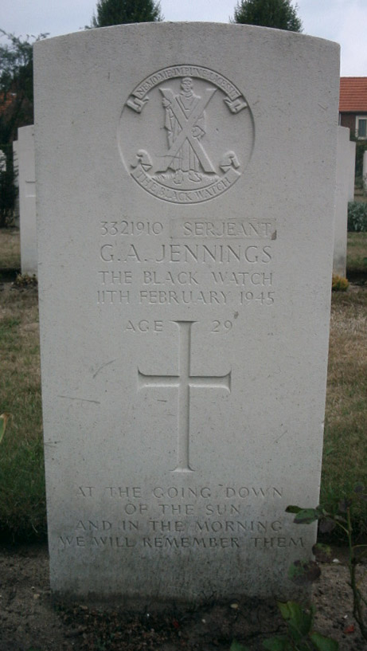 | 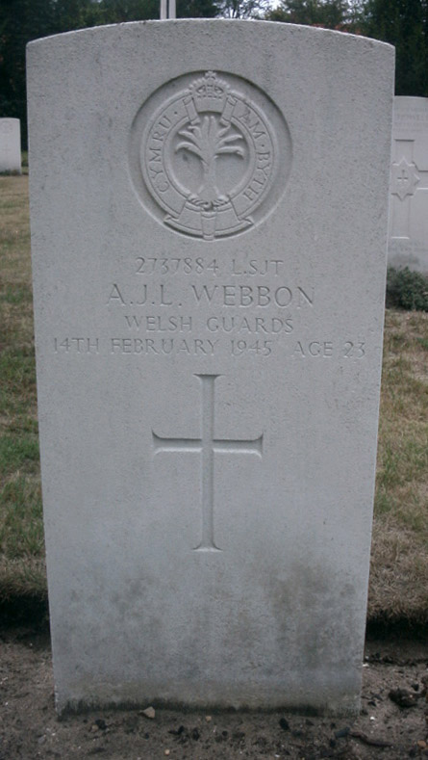
Serjeant George A. JENNINGS  5th Battalion, Black Watch (Royal Highlanders),  153rd Infantry Brigade,  51st (Highland) Infantry Division  KIA 11-02-1945  Veldgraf: P.J. Geurts, Nijmeegscheweg 27  Begraven: Milsbeek War Cemetery II.A.9 | Lance Serjeant Arhtur J.L. WEBBON  1st Battalion, Welsh Guards,  32nd Guards Infantry Brigade,  Guards Armoured Division  KIA 14-02-1945  Veldgraf: F. Derks, Nijmeegscheweg  Begraven: Milsbeek War Cemetery II.B.1

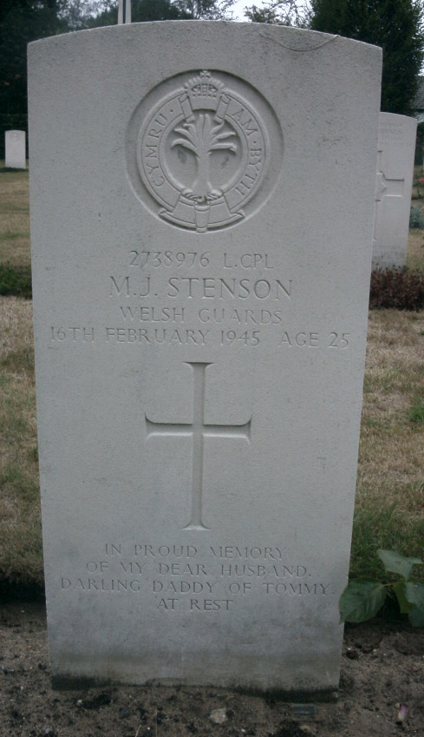 | 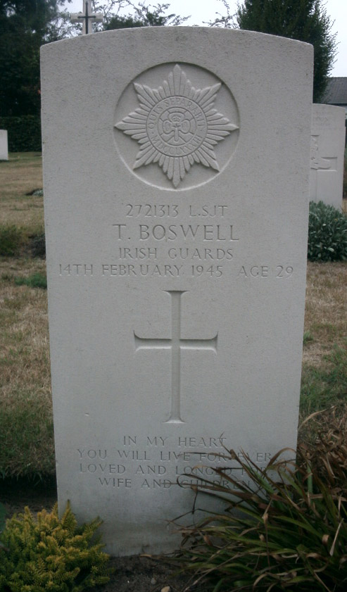
Lance Corporal Michael J. STENSON  1st Battalion, Welsh Guards,  32nd Guards Infantry Brigade,  Guards Armoured Division  KIA 16-02-1945  Veldgraf: Groene Kruisstraat  Begraven: Milsbeek War Cemetery II.B.2 | Lance Serjeant Thomas BOSWELL  3rd Battalion, Irish Guards,  32nd Guards Infantry Brigade,  Guards Armoured Division  KIA 14-02-1945  Veldgraf: F. Derks, Nijmeegscheweg  Begraven: Milsbeek War Cemetery II.B.3

