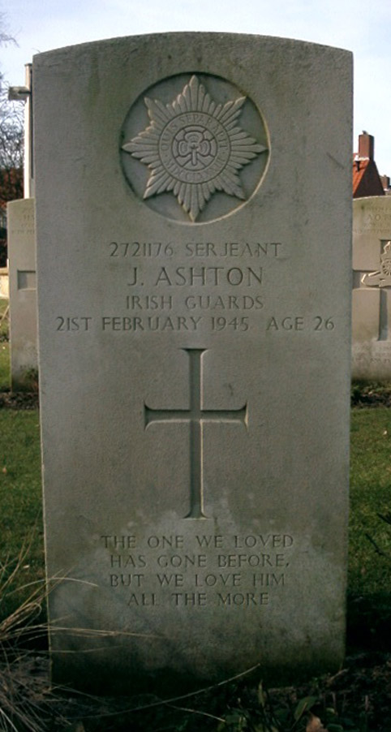 | 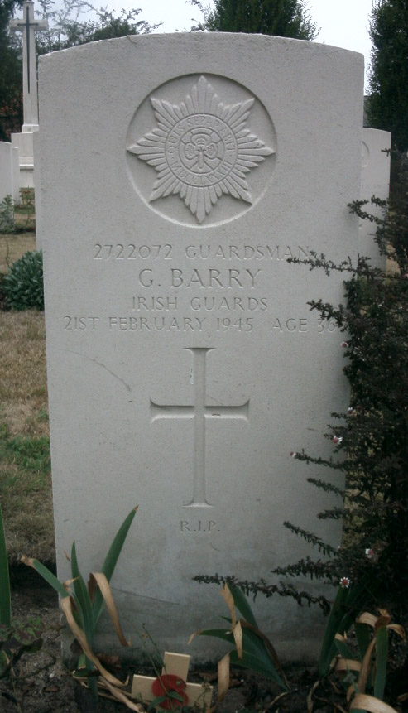
Serjeant John ASHTON  3rd Battalion, Irish Guards,  32nd Guards Infantry Brigade,  Guards Armoured Division  KIA 21-02-1945  Veldgraf: Groene Kruisstraat  Begraven: Milsbeek War Cemetery II.B.4 | Guardsman Gerald BARRY  3rd Battalion, Irish Guards,  32nd Guards Infantry Brigade,  Guards Armoured Division  KIA 21-02-1945  Veldgraf: Groene Kruisstraat  Begraven: Milsbeek War Cemetery II.B.5

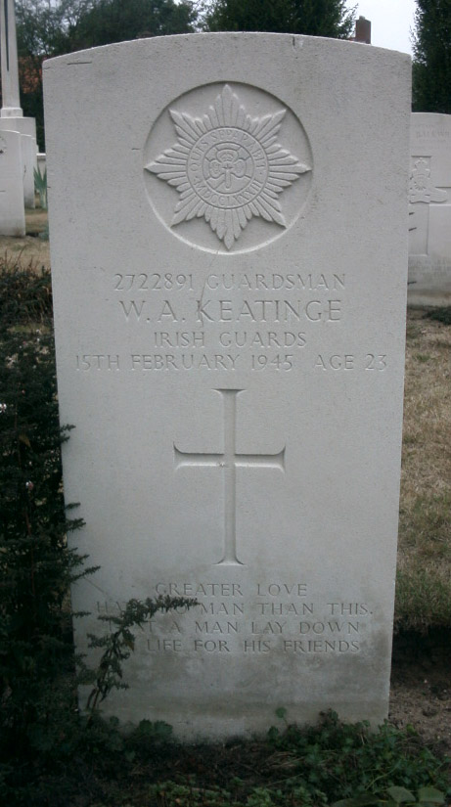 | 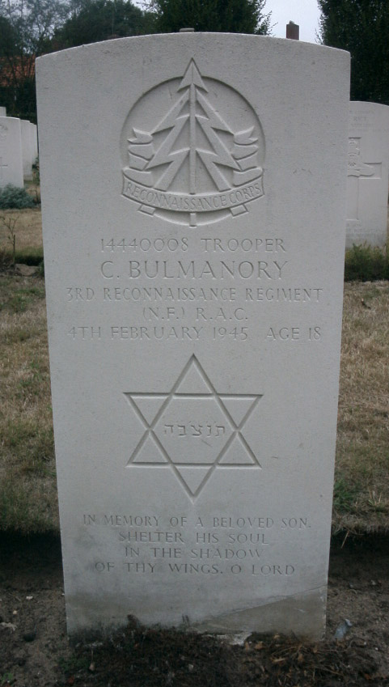
Guardsman William A. KEATINGE  3rd Battalion, Irish Guards,  32nd Guards Infantry Brigade,  Guards Armoured Division  KIA 15-02-1945  Veldgraf: Openbare L.O. School  Begraven: Milsbeek War Cemetery II.B.6 | Trooper Cyril BULMANORY  3rd (8th Bn. The Royal Northumberland Fusiliers)Regt,  R.A.C.  KIA 04-02-1945  Veldgraf: Maasbrug Noordzijde  Begraven: Milsbeek War Cemetery II.B.7

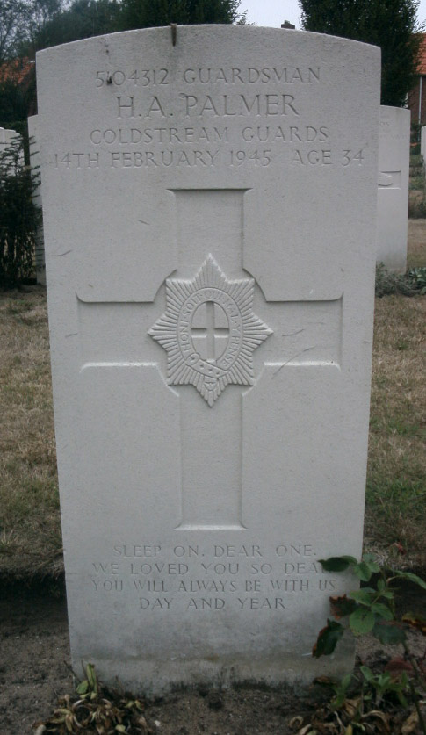 | 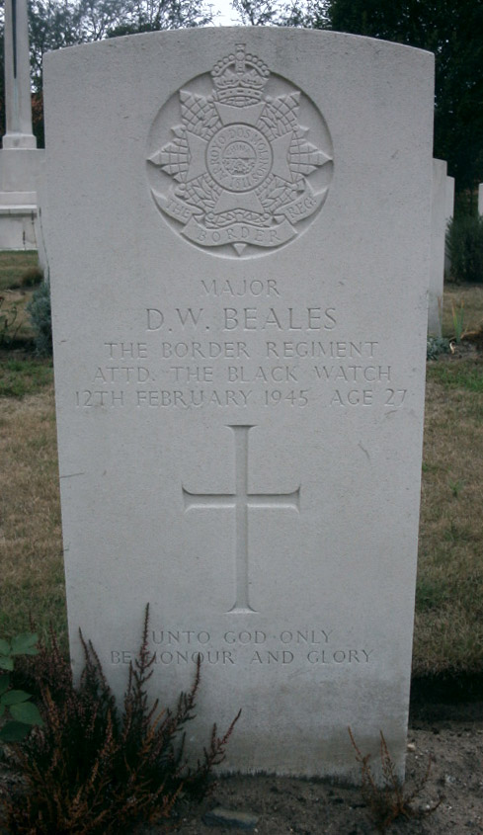
Guardsman Horace A. PALMER  5th Battalion, Coldstream Guards,  32nd Guards Infantry Brigade,  Guards Armoured Division  KIA 14-02-1945  Veldgraf: W. Venhoven, Breedeweg 20  Begraven: Milsbeek War Cemetery II.B. | Major Donald W. BEALE  Attd. 5th Battalion, Black Watch (Royal Highlanders),  153rd Infantry Brigade,  51st (Highland) Infantry Division  KIA 12-02-1945  Begraven: Milsbeek War Cemetery II.D.3

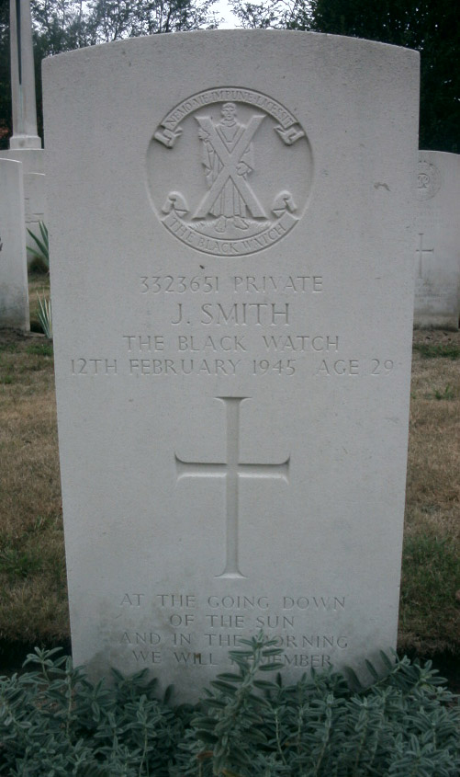 | 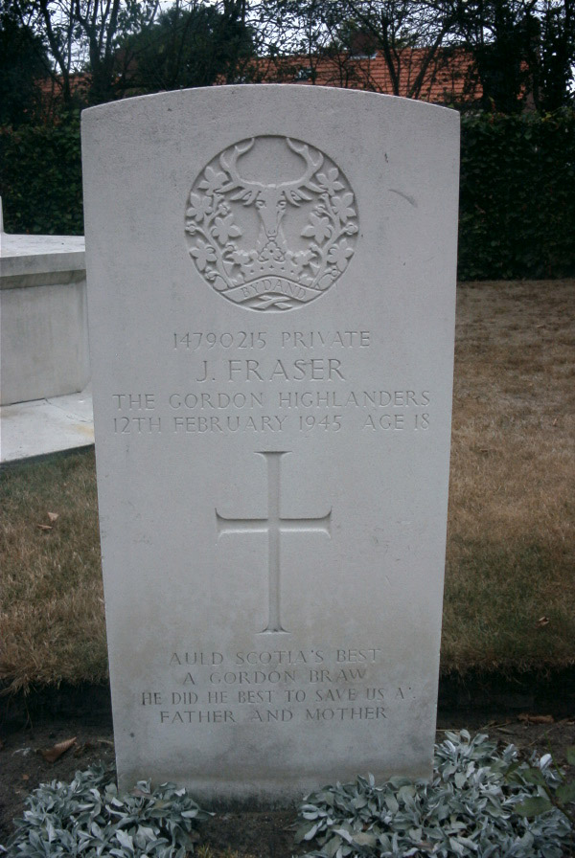
Private John SMITH  5th Battalion, Black Watch (Royal Highlanders),  153rd Infantry Brigade,  51st (Highland) Infantry Division  KIA 12-02-1945  Begraven: Milsbeek War Cemetery II.D.4 | Private John FRASER  5/7th Battalion, Gordon Highlanders,  153rd Infantry Brigade,  51st (Highland) Infantry Division  KIA 12-02-1945  Veldgraf: P.J. Geurts, Nijmeegscheweg 27  Begraven: Milsbeek War Cemetery II.D.4

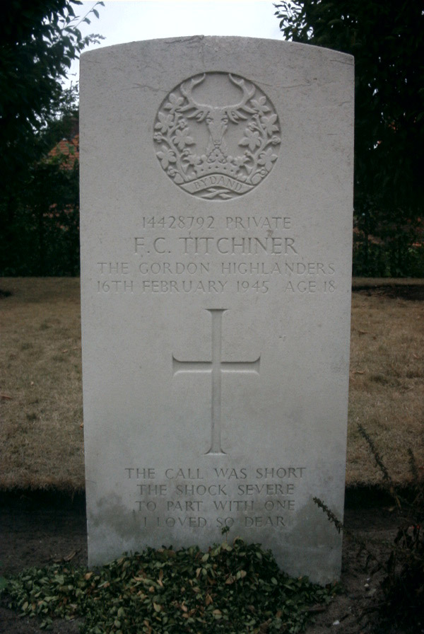 | 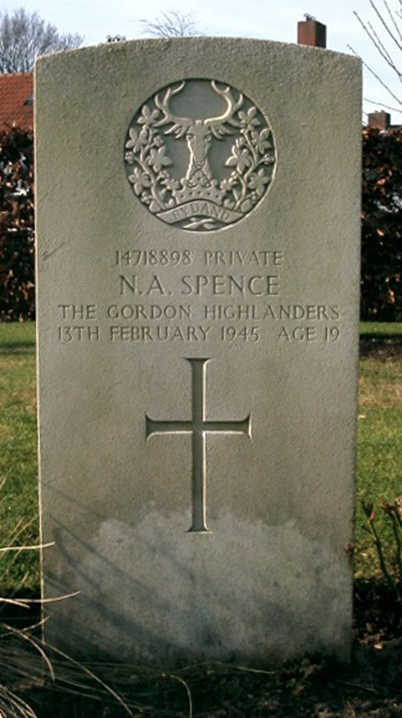
Private Frederick C. TITCHINER  1st Battalion, Gordon Highlanders,  153rd Infantry Brigade,  51st (Highland) Infantry Division  KIA 16-02-1945  Veldgraf: Openbare L.O. School  Begraven: Milsbeek War Cemetery II.G.10 | Private Norman A. SPENCE  1st Battalion, Gordon Highlanders,  153rd Infantry Brigade,  51st (Highland) Infantry Division  KIA 13-02-1945  Veldgraf: Openbare L.O. School  Begraven: Milsbeek War Cemetery II.G.11

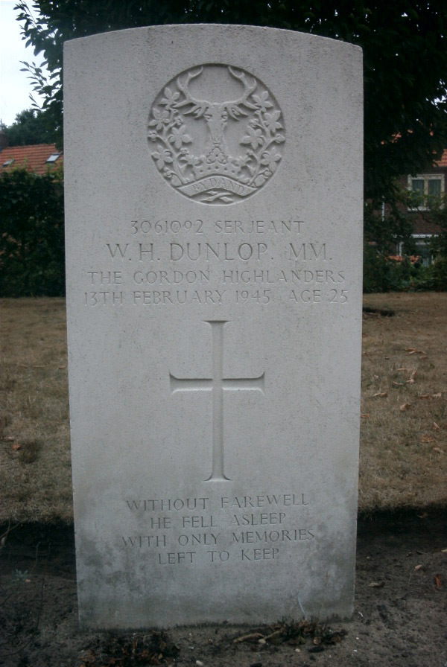 | 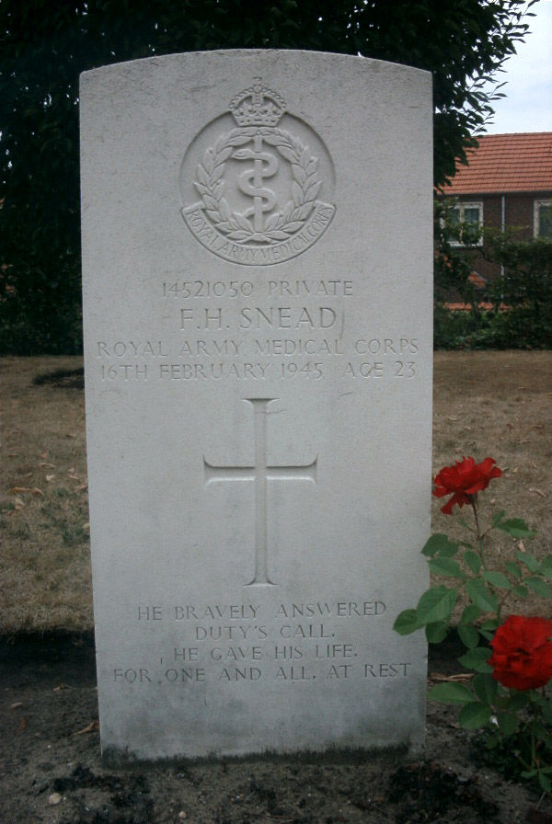
Serjeant William H. DUNLOP  1st Battalion, Gordon Highlanders,  153rd Infantry Brigade,  51st (Highland) Infantry Division  KIA 13-02-1945  Veldgraf: Openbare L.O. School  Begraven: Milsbeek War Cemetery II.G.12 | Private Frank H. SNEAD  128 Field Amb., R.A.M.C.  KIA 16-02-1945  Veldgraf: Groene Kruisstraat  Begraven: Milsbeek War Cemetery II.G.13

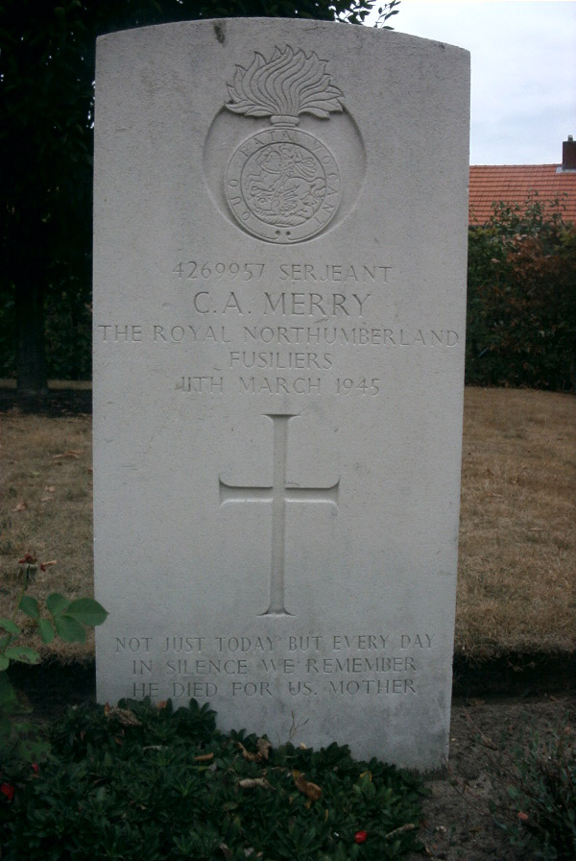 | 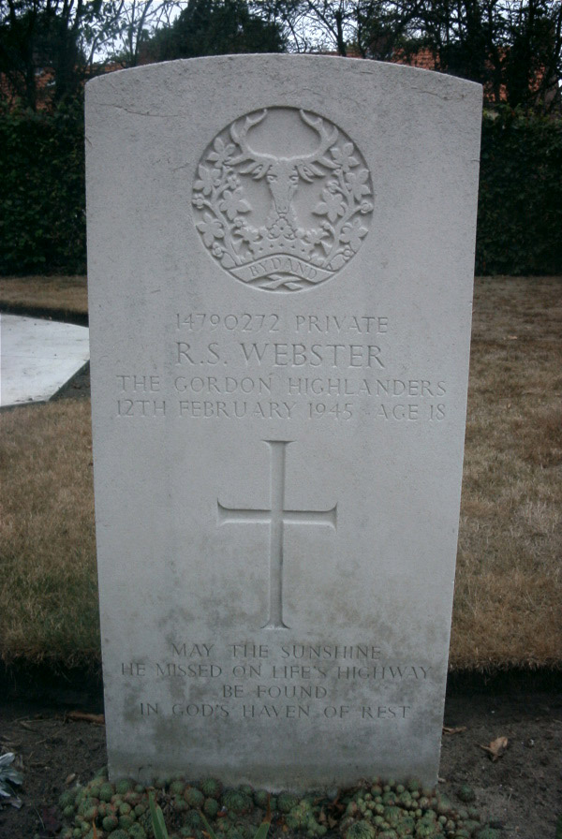
Serjeant Charles A. MERRY  Royal Northumberland Fusiliers  KIA 11-03-1945  Veldgraf: F. Derks, Nijmeegscheweg  Begraven: Milsbeek War Cemetery II.G.13 | Private Robert S. WEBSTER  5/7th Battalion, Gordon Highlanders,  153rd Infantry Brigade,  51st (Highland) Infantry Division  KIA 12-02-1945  Veldgraf: P.J. Geurts, Nijmeegscheweg 27  Begraven: Milsbeek War Cemetery II.G.2

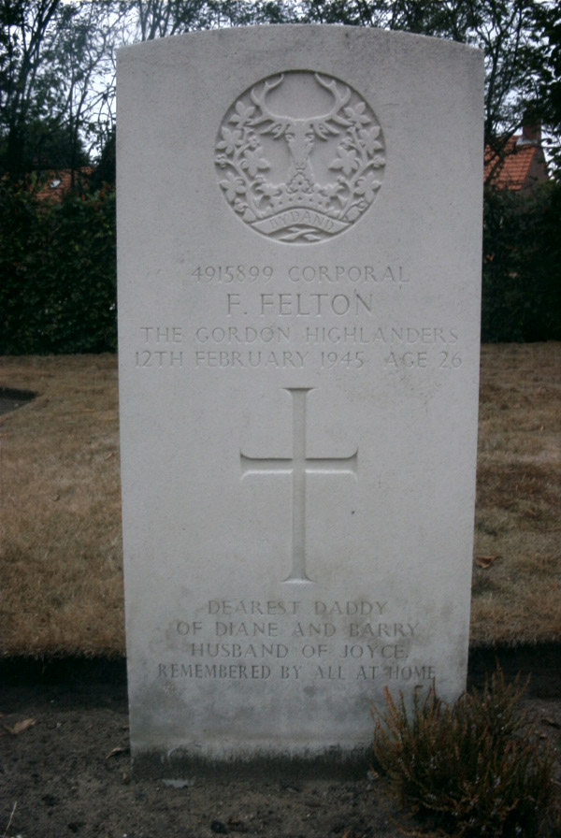 | 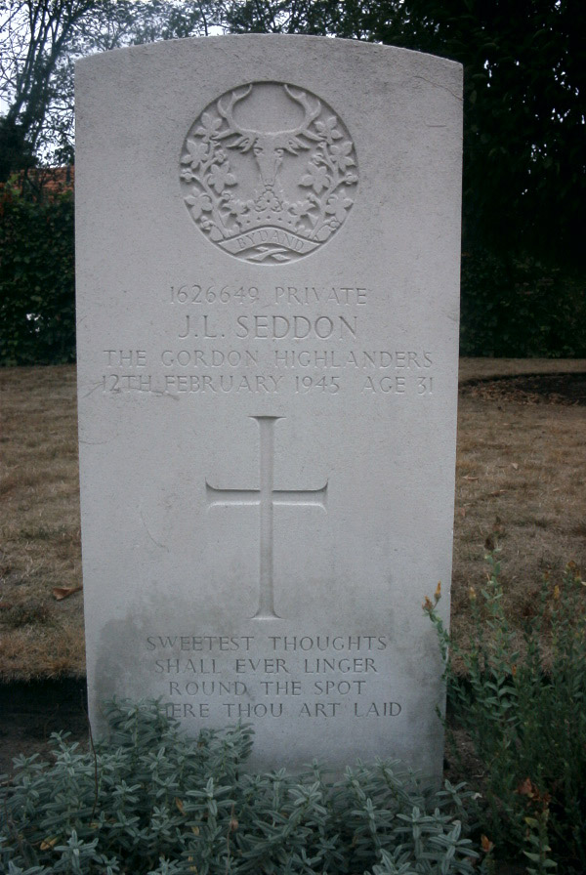
Corporal Frank FELTON  5/7th Battalion, Gordon Highlanders,  153rd Infantry Brigade,  51st (Highland) Infantry Division  KIA 12-02-1945  Veldgraf: P.J. Geurts, Nijmeegscheweg 27  Begraven: Milsbeek War Cemetery II.G.3 | Private John L. SEDDON  5/7th Battalion, Gordon Highlanders,  153rd Infantry Brigade,  51st (Highland) Infantry Division  KIA 12-02-1945  Veldgraf: P.J. Geurts, Nijmeegscheweg 27  Begraven: Milsbeek War Cemetery II.G.4

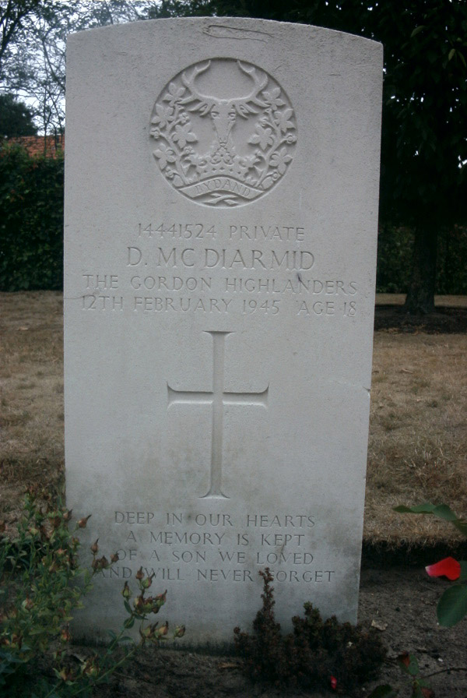 | 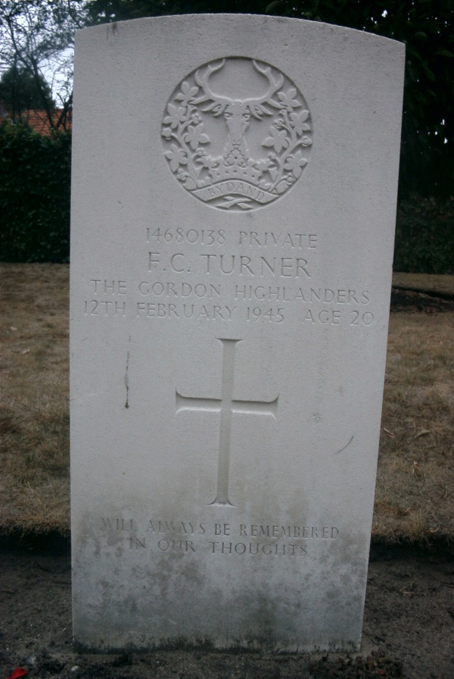
Private Duncan McDIARMID  5/7th Battalion, Gordon Highlanders,  153rd Infantry Brigade,  51st (Highland) Infantry Division  KIA 12-02-1945  Veldgraf: P.J. Geurts, Nijmeegscheweg 27  Begraven: Milsbeek War Cemetery II.G.5 | Private Frederick C. TURNER  5/7th Battalion, Gordon Highlanders,  153rd Infantry Brigade,  51st (Highland) Infantry Division  KIA 12-02-1945  Veldgraf: P.J. Geurts, Nijmeegscheweg 27  Begraven: Milsbeek War Cemetery II.G.6

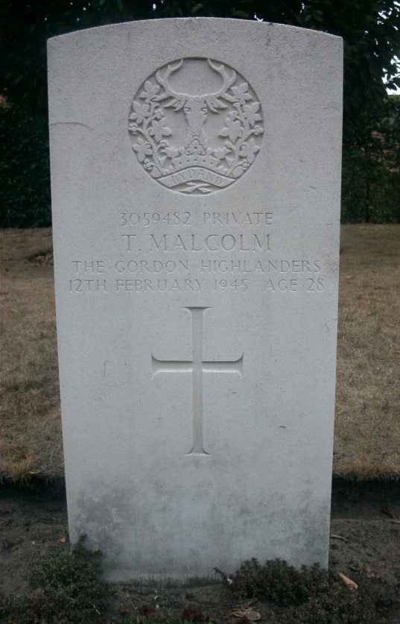 | 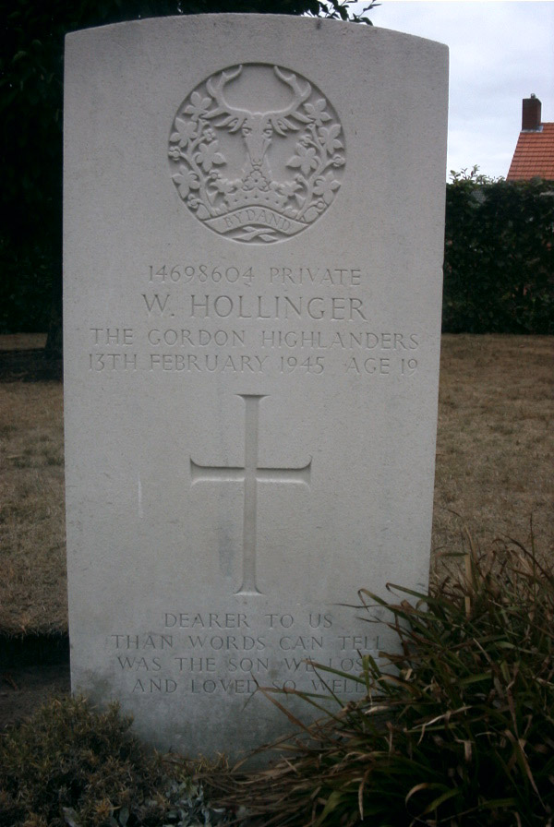
Private Thomas MALCOLM  5/7th Battalion, Gordon Highlanders,  153rd Infantry Brigade,  51st (Highland) Infantry Division  KIA 12-02-1945  Veldgraf: P.J. Geurts, Nijmeegscheweg 27  Begraven: Milsbeek War Cemetery II.G.7 | Private William HOLLINGER  5/7th Battalion, Gordon Highlanders,  153rd Infantry Brigade,  51st (Highland) Infantry Division  KIA 13-02-1945  Veldgraf: P.J. Geurts, Nijmeegscheweg 27  Begraven: Milsbeek War Cemetery II.G.8

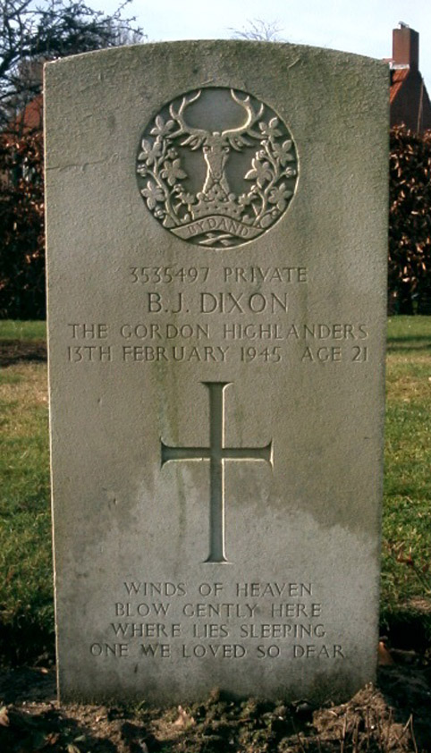 | Nog geen foto beschikbaar
Private Bernard J. DIXON  1st Battalion, Gordon Highlanders,  153rd Infantry Brigade,  51st (Highland) Infantry Division  KIA 13-02-1945  Veldgraf: Openbare L.O. School  Begraven: Milsbeek War Cemetery II.G.9 | Gunner William E. TRODD  107 (The South Notts. Hussars) Regt ,  Royal Horse Artillery  KIA 21-02-1945  Veldgraf: R.K. Kerkhof Noordzijde  Begraven: Jonkerbos War Cemetery 2.B5

